Kyle Kasmiersky
3/2/26
Professor Luo
Homework 3 Kasmiersky
- Consider the following diagram with masses, dampers, and springs. The constitutive law constants are $K_{i},m_{i}, and b_{i},$ where $i$ stands for the index of the component.
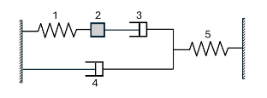
- Write out newtons laws without plugging in constitutive laws for this system
$$-f_{1}+f_{3}=m_{2}a_{2}$$
$$-f_{3}-f_{4}+f_{5}=0$$
- Write out all the kinematic constraint equations.
$$v_{1}+v_{3}=v_{4}$$
$$v_{1}+v_{3}+v_{5}=0$$
$$v_{4}+v_{5}=0$$
$$v_{1}=v_{2}$$
- Write out the constitutive laws for each component.
$$f_{1}=k_{1}x_{1}$$
$$f_{3}=b_{3}v_{3}$$
$$f_{4}=b_{4}v_{4}$$
$$f_{5}=b_{5}v_{5}$$
- How many state variables does this system have? What are they?
3 state variable (one mass, two springs)
$$x_{1},\dot{x_{1}},x_{5}$$

- Derive the state equations for this system. Write it out in matrix form.
$$-f_{3}-f_{4}+f_{5}=0$$
$$-b_{3}v_{3}-b_{4}v_{4}+k_{5}x_{5}=0$$
$$-b_{3}v_{3}+b_{4}v_{5}+k_{5}x_{5}=0$$
$$b_{4}v_{5}=b_{3}v_{3}-k_{5}x_{5}$$
$$b_{4}v_{5}=b_{3}\left(-v_{1}-v_{5}\right)-k_{5}x_{5}$$
$$\left(b_{3}+b_{4}\right)v_{5}=b_{3}\left(-v_{1}\right)-k_{5}x_{5}$$
$$v_{5}=-\frac{b_{3}}{b_{3}+b_{4}}\left(v_{1}\right)-\frac{k_{5}}{b_{3}+b_{4}}x_{5}$$

$$-f_{1}+f_{3}=m_{2}a_{2}$$
$$-k_{1}x_{1}+b_{3}v_{3}=m_{2}a_{2}$$
$$-k_{1}x_{1}-b_{3}v_{1}-b_{3}v_{5}=m_{2}a_{2}$$
$$-k_{1}x_{1}-b_{3}v_{1}+b_{3}\left(\frac{b_{3}}{b_{3}+b_{4}}\left(v_{1}\right)+\frac{k_{5}}{b_{3}+b_{4}}x_{5}\right)=m_{2}a_{2}$$
$$-k_{1}x_{1}-b_{3}v_{1}+\frac{b_{3}^{2}}{b_{3}+b_{4}}\left(v_{1}\right)+\frac{b_{3}k_{5}}{b_{3}+b_{4}}x_{5}=m_{2}a_{2}$$
$$a_{2}=-\frac{k_{1}}{m_{2}}x_{1}-\frac{b_{3}}{m_{2}}v_{1}+\frac{b_{3}^{2}}{{m_{2}(b}_{3}+b_{4}) }\left(v_{1}\right)+\frac{b_{3}k_{5}}{{m_{2}(b}_{3}+b_{4})}x_{5}$$
$$\left[\begin{matrix}\dot{x_{1}} \\ \ddot{x_{1}} \\ \dot{x_{5}}\end{matrix}\right]=\left[\begin{matrix}0 & 1 & 0 \\ -\frac{k_{1}}{m_{2}} & -\frac{b_{3}}{m_{2}}+\frac{b_{3}^{2}}{{m_{2}(b}_{3}+b_{4}) } & \frac{b_{3}k_{5}}{{m_{2}(b}_{3}+b_{4})} \\ 0 & -\frac{b_{3}}{b_{3}+b_{4}} & -\frac{k_{5}}{b_{3}+b_{4}}\end{matrix}\right]\left[\begin{matrix}x_{1} \\ \dot{x_{1}} \\ x_{5}\end{matrix}\right]$$
- For each statement below, mark T if the statement is true and F if the statement is false. A statement is false if its not always true.
- If $\dot{v_{2}}>-, then f_{3}-f_{1}>0$ True
- If$x_{5}>0, then v_{4}>0$ False
- If $x_{1}>0, then v_{3}>0$ False

- Converting the following ODEs into systems of first-order ODEs by change of variables

$$x=u_{1}$$
$$\dot{x}=u_{2}$$

$$\dot{u_{1}}=u_{2}$$
$$\dot{u_{2}}=-\sin\left(t\right)u_{2}$$

$$u_{1}=x$$
$$u_{2}=\dot{x}$$
$$u_{3}=\ddot{x}$$

$$\dot{u_{1}}=u_{2}$$
$$\dot{u_{2}}=u_{3}$$
$$\dot{u_{3}}=-u_{2}u_{3}$$

$$u_{1}=x$$
$$u_{2}=\dot{x}$$
$$u_{3}=\ddot{x}$$

$$\dot{u_{1}}=u_{2}$$
$$\dot{u_{2}}=u_{3}$$
$$\dot{u_{3}}=-t^{2}u_{3}+u_{1}+3t$$

- Complex numbers and Euler’s formula
- Use Taylor series to expand $\sin\left(ωt\right)$ and $\cos\left(ωt\right)$. Write out the first 5 terms in the series expansion, and compare them with the real and imaginary part of $e^{iωt}$ in the lecture notes.
Assuming the taylor series about 0
$$\sin\left(ωt\right)≈\sin\left(ω0\right)+\frac{ωcos\left(ω0\right)}{1}t-\frac{ω^{2}\sin\left(ω0\right)}{2}t^{2}-\frac{ω^{3}cos\left(ω0\right)}{6}t^{3}+\frac{ω^{4}\sin\left(ω0\right)}{24}t^{4}$$
$$\cos\left(ωt\right)≈\cos\left(ω0\right)-\frac{ω\sin\left(ω0\right)}{1}t-\frac{ω^{2}\cos\left(ω0\right)}{2}t^{2}+\frac{ω^{3}\sin\left(ω0\right)}{6}t^{3}+\frac{ω^{4}\cos\left(ω0\right)}{24}t^{4}$$
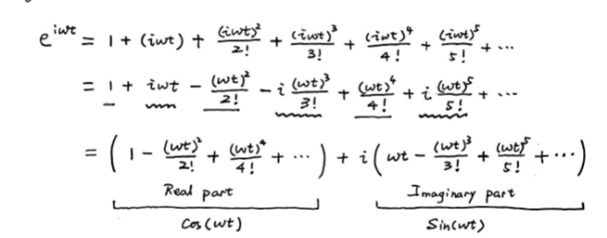
The Taylor series expansions are identical to the imaginary and real parts of the Euler identity, respectively.
$$\frac{a+ib}{c+id}=\frac{a+ib}{c+id}$$
$$\frac{\left(a+ib\right)\left(c-id\right)}{c^{2}+d^{2}}=\frac{a+ib}{c+id}$$
$$\frac{ac+bd+i\left(bc-ad\right)}{c^{2}+d^{2}}=\frac{a+ib}{c+id}$$
$$\frac{\sqrt{a^{2}c^{2}+2abcd+b^{2}d^{2}+\left(a^{2}d^{2}-2abcd+b^{2}c^{2}\right)}}{c^{2}+d^{2}}=\frac{\sqrt{a^{2}+b^{2}}}{\sqrt{c^{2}+d^{2}}}$$
$$\frac{\sqrt{a^{2}c^{2}+b^{2}d^{2}+a^{2}d^{2}+b^{2}c^{2}}}{c^{2}+d^{2}}=\frac{\sqrt{a^{2}+b^{2}}}{\sqrt{c^{2}+d^{2}}}$$
$$\frac{\sqrt{a^{2}c^{2}+b^{2}d^{2}+a^{2}d^{2}+b^{2}c^{2}}}{c^{2}+d^{2}}=\frac{\sqrt{a^{2}+b^{2}}}{\sqrt{c^{2}+d^{2}}}\frac{\sqrt{c^{2}+d^{2}}}{\sqrt{c^{2}+d^{2}}}$$
$$\frac{\sqrt{a^{2}c^{2}+b^{2}d^{2}+a^{2}d^{2}+b^{2}c^{2}}}{c^{2}+d^{2}}=\frac{\sqrt{a^{2}c^{2}+a^{2}d+b^{2}c^{2}+b^{2}d^{2}}}{c^{2}+d^{2}}$$
$$argument$$
$$\tan^{-1}\left(\frac{bc-ad}{ac+bd}\right)=\tan^{-1}\left(\frac{b}{a}\right)-\tan^{-1}\left(\frac{d}{c}\right)$$
$$\tan^{-1}\left(\frac{bc-ad}{ac+bd}\right)=\tan^{-1}\left(\frac{\frac{b}{a}-\frac{d}{c}}{1+\frac{bd}{ac}}\right)$$
$$\tan^{-1}\left(\frac{bc-ad}{ac+bd}\right)=\tan^{-1}\left(\frac{ac\frac{b}{a}-ac\frac{d}{c}}{ac+bd}\right)$$
$$\tan^{-1}\left(\frac{bc-ad}{ac+bd}\right)=\tan^{-1}\left(\frac{bc-ad}{ac+bd}\right)$$
$$z=Ae^{iθ}$$
$$dz=iAe^{iθ}dθ$$
$$dz=izdθ$$
When z lengthens, both sides of the equation length by the change in z. the RHS is multiplies by i so because changes in $zdθ$ happen at 90 degrees to z when only theta is changing.
Answers given in: magnitude; direction
$$2+i\sqrt{3}$$
$$\sqrt{4+3}=\sqrt{7};\tan^{-1}\left(\frac{\sqrt{3}}{4}\right)$$
$${\left(2-i\sqrt{3}\right)}^{2}=4-3-i4\sqrt{3}$$
$$\sqrt{1+48}=7;\tan^{-1}\left(\left(\frac{4\sqrt{3}}{1}\right)\right)$$
- 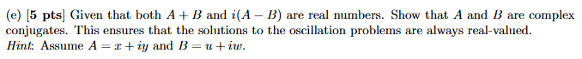
By definition, if A and B are complex conjugates, then $y=-w$

If
$$A+B=u+x+i\left(y+w\right)=real_num$$
Then
$$i\left(y+w\right)=0$$
$$y+w=0$$
$$y=-w$$
- 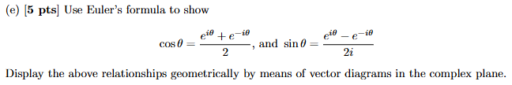
$$\frac{e^{iθ}+e^{-iθ}}{2}$$
$$\frac{\cos\left(θ\right)+isin\left(θ\right)+\cos\left(-θ\right)+isin\left(-θ\right)}{2}$$
$$\frac{\cos\left(θ\right)+isin\left(θ\right)+\cos\left(θ\right)-isin\left(θ\right)}{2}$$
$$\frac{2\cos\left(θ\right)}{2}=\cos\left(θ\right)$$

$$\frac{e^{iθ}-e^{-iθ}}{2i}$$
$$\frac{\cos\left(θ\right)+isin\left(θ\right)-\cos\left(-θ\right)-isin\left(-θ\right)}{2i}$$
$$\frac{\cos\left(θ\right)+isin\left(θ\right)-\cos\left(θ\right)+isin\left(θ\right)}{2i}$$

$$\frac{isin\left(θ\right)+isin\left(θ\right)}{2i}=\sin\left(θ\right)$$

- Consider the mass spring system a :
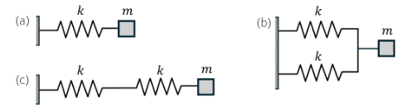
- Obtain its equation of motion using force balance, continuity and constitutive laws
$$-f_{k}=ma_{m}$$
$$-kx_{k}=ma_{m}$$
$$-kx=ma \left(displacements equal.\right)$$
$$\ddot{x}=-\frac{k}{m}x$$
- Plug in the exponential solution into the equation of motion and obtain the natural freq.
$$λ^{2}x_{0}e^{λt}=-\frac{k}{m}x_{0}e^{λt}$$
$$λ^{2}=ω^{2}=-\frac{k}{m}$$
$$ω=\sqrt{-\frac{k}{m}}$$
$$b: λ^{2}x_{0}e^{λt}=-\frac{k_{1}}{m}x_{0}e^{λt}-\frac{k_{2}}{m}x_{0}e^{λt}$$
$$λ^{2}=ω^{2}=-\frac{k_{1}+k_{2}}{m}$$
$$ω=\sqrt{-\frac{k_{1}+k_{2}}{m}}$$
$$c:λ^{2}x_{0}e^{λt}=-\frac{\frac{1}{k_{1}}+\frac{1}{k_{2}}}{m}x_{0}e^{λt}$$
$$ω=\sqrt{-\frac{\frac{1}{k_{1}}+\frac{1}{k_{2}}}{m}}$$
For the series and normal springs, increasing spring constant increases natural frequency, while in the series spring system it decreases natural frequency.
- 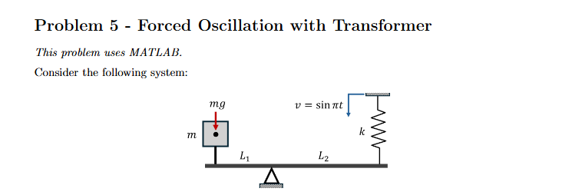
- Write out newtons laws without plugging in constitutive laws for this system
$$-F_{g}L_{1}+L_{2}{F_{k}}_{L2}=L_{1}ma_{m}$$
- Write out all the kinematic constraint equations.
$$\frac{x_{m}}{L_{1}}=-\frac{x_{k}}{L_{2}}$$
- Derive the state equation for this system. Write it out in matrix form.
$$-mgL_{1}+L_{2}kx_{k}=L_{1}ma_{m}$$
$$a_{m}=-g+\frac{L_{2}}{L_{1}}\frac{k}{m}x_{k}$$
$${\ddot{x}}_{m}=-g+\frac{L_{2}}{L_{1}}\frac{k}{m}x_{k}$$
$${\ddot{x}}_{m}=-g+\frac{L_{2}}{L_{1}}\frac{k}{m}\left(-\frac{L_{2}}{L_{1}}x_{m}\right)$$
$${\ddot{x}}_{m}=-g-\frac{L_{2}^{2}}{L_{1}^{2}}\frac{k}{m}x_{m}$$
$$\ddot{x}=-g-\frac{L_{2}^{2}}{L_{1}^{2}}\frac{k}{m}x$$

$$\left[\begin{aligned}\dot{x} \\ \ddot{x}\end{aligned}\right]=\left[\begin{matrix}0 & 1 \\ -\frac{L_{2}^{2}}{L_{1}^{2}}\frac{k}{m} & 0\end{matrix}\right]\left[\begin{aligned}x \\ \dot{x}\end{aligned}\right]+\left[\begin{aligned}0 \\ -g\end{aligned}\right]$$

- Assume the spring is at its natural length when the level is in a horizontal position. Calculate the spring’s extension at static equilibrium using the following constants: m = 0.5kg, g = 9.81, k = 1, L1 = 1m, L2 = 2m.
$$-mgL_{1}+L_{2}kx_{k}=L_{1}ma_{m}$$
$$-mgL_{1}+L_{2}kx_{k}=0$$
$$x_{k}=\frac{mgL_{1}}{L_{2}k}=\frac{0.5*-9.81*1}{2*1}=-\frac{9.81}{4}$$
- Suppose the system starts with $x_{S}\left(0\right)=0$ and $v_{m}\left(0\right)=0$. Use the constants in part d and euler integration to approximate the solution for $t=0<t<40$. Plot x and v.
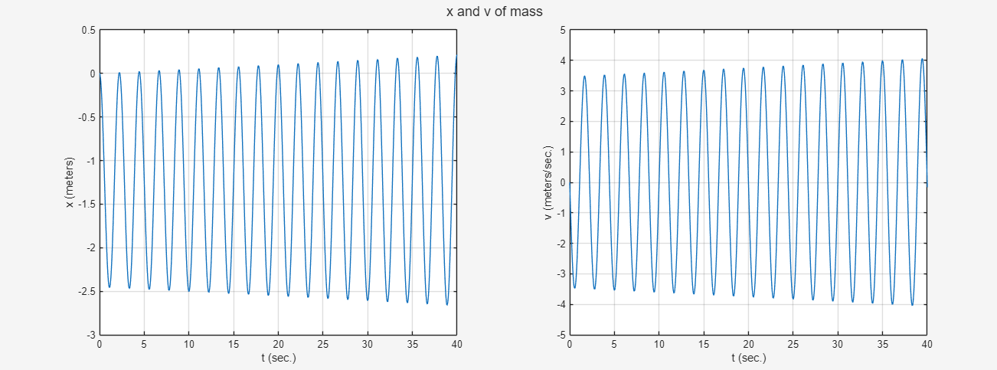
- Repeat part e with v = sin(2.8t) compare results.
